# Table of Participants

**Future University in Egypt**

**Faculty of Computers and Information Technology**

**Department of Computer Science**

Group : B1.2

|  |  |
| --- | --- |
| *Prepared by* | |
| ID | Name |
| 20190374 | Omar Mostafa Hefni |
| 20190577 | George Ayad |
| 20195198 | Mohamed Emad |
| 20192716 | Sherif Aly Saad |

# 

**Supervised by**

**Prof. Ramadan Moawad**

**TA. Amr Mansour**

# Architecture Design

|  |
| --- |
| Verify the user's payment method |

**Payment view Controller**

|  |
| --- |
| Select Payment Method  Reservation is Initiated  Add Payment Card Details  Accept Payment  Send Recipet |

**From to display**

**User events**

|  |
| --- |
| **El-Mal3ab Database**  **for Payment** |

**Change notification** **Model**

**Refresh request Update request**

# Initial Class

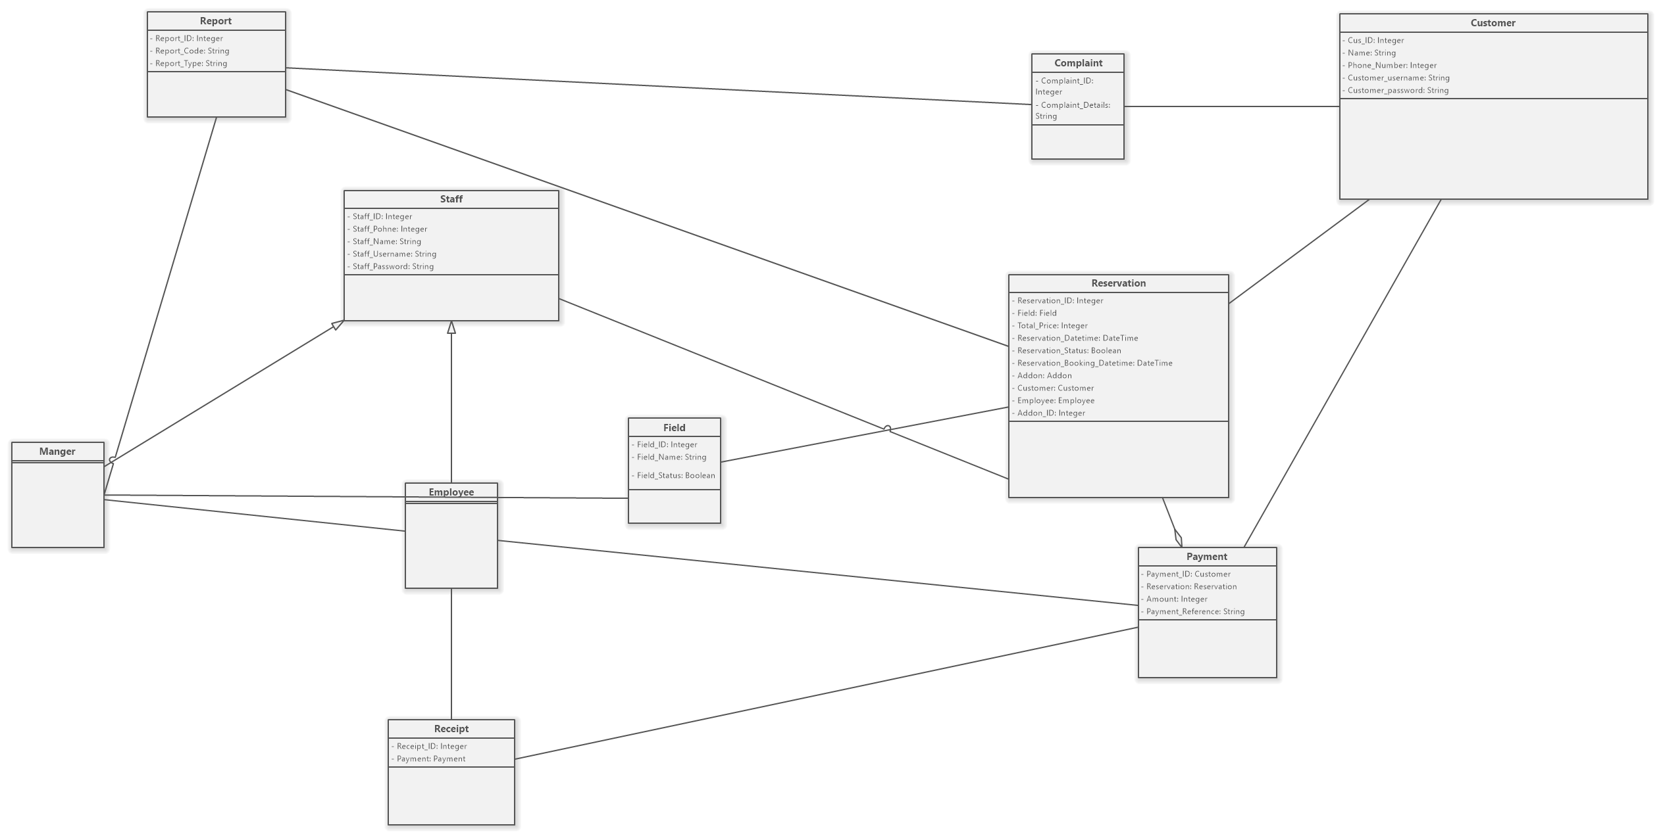

# Use Case Diagram

# Class Diagram

# 

# Sequence Diagrama.1

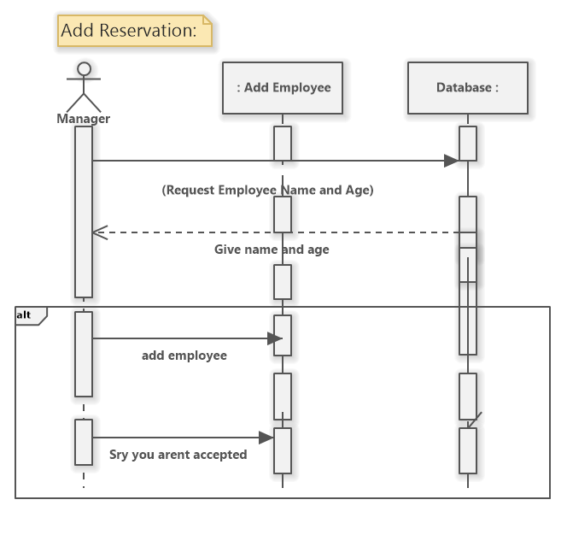a.2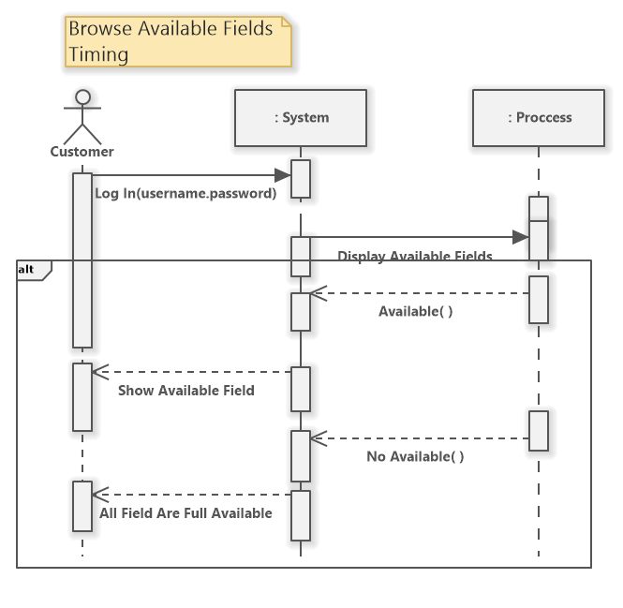a.3a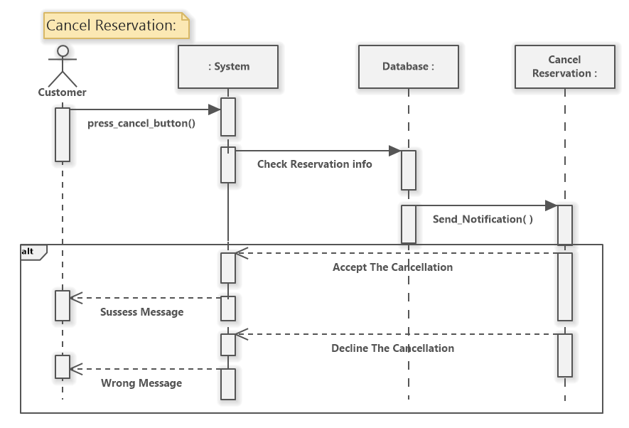a.4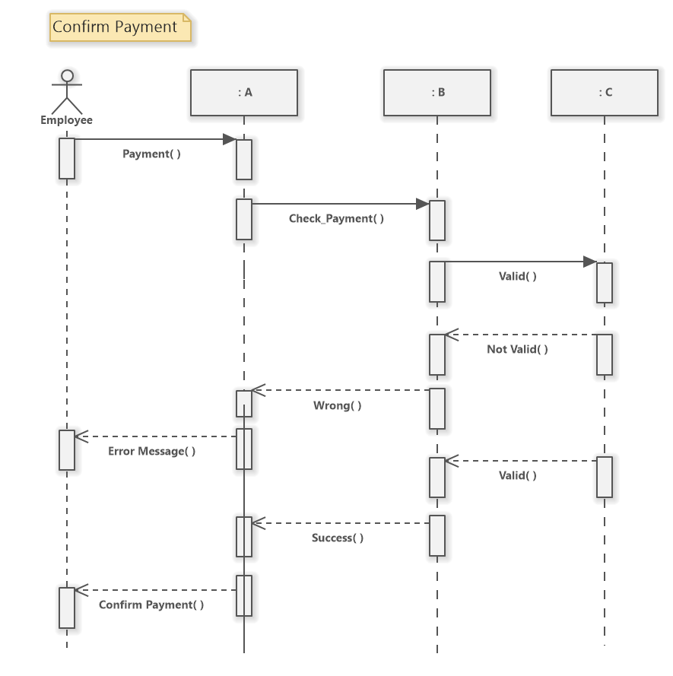a.5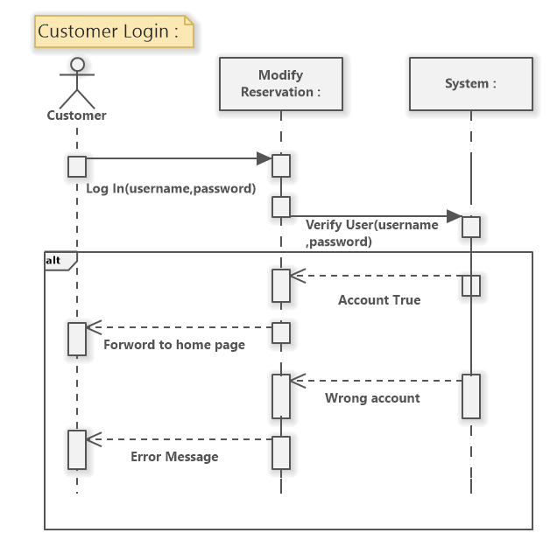a.6 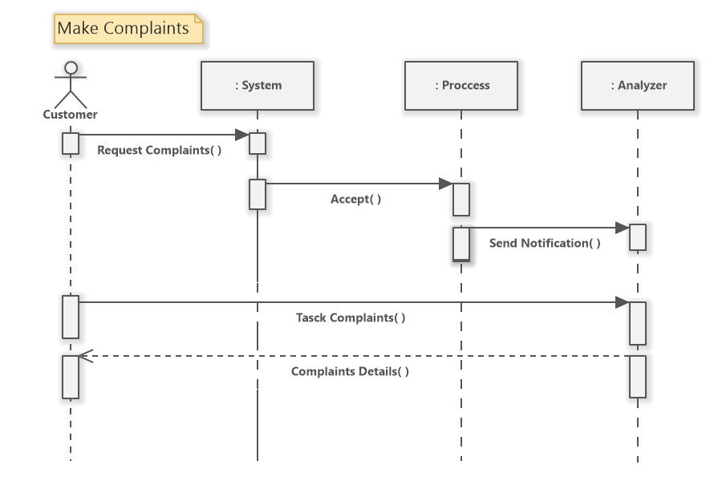a.7

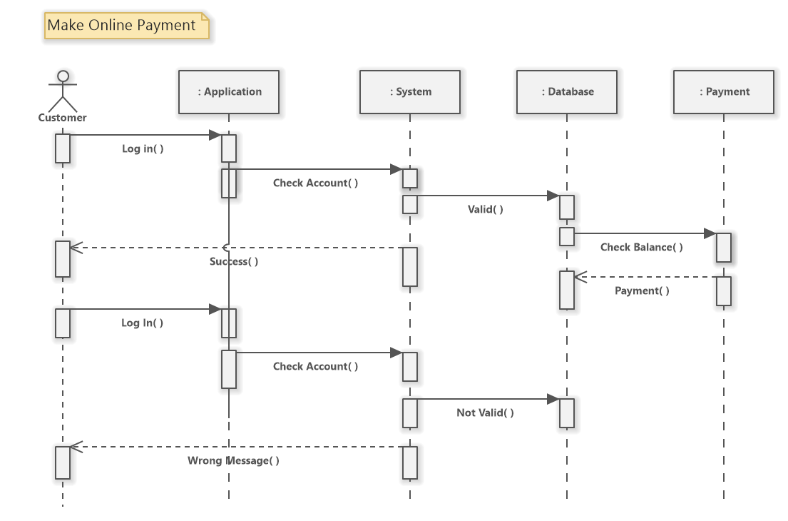A.8

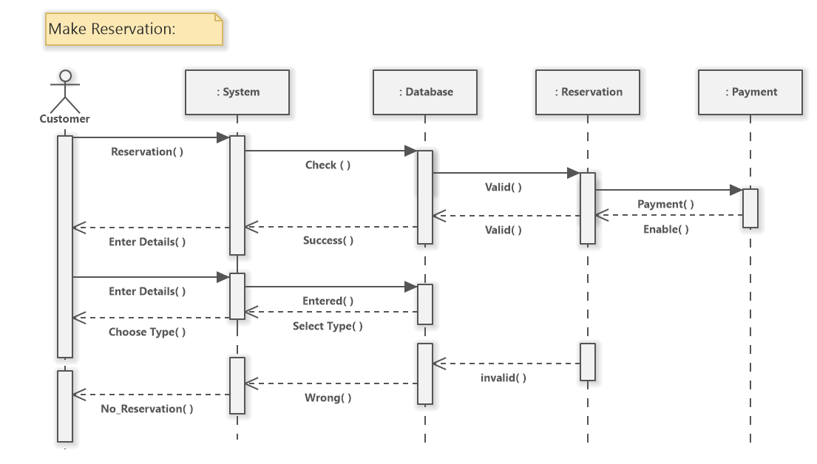A.9

A.10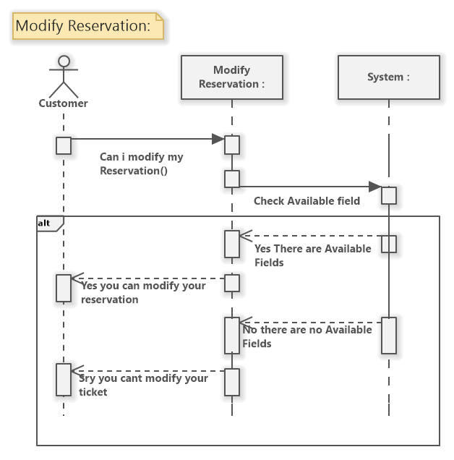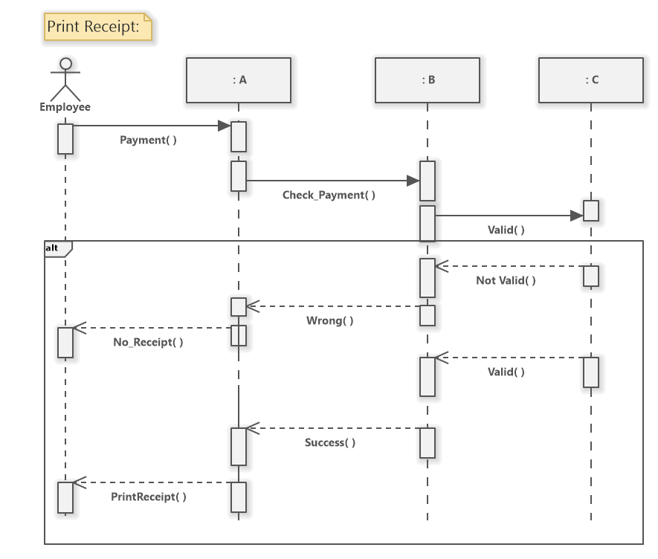A.11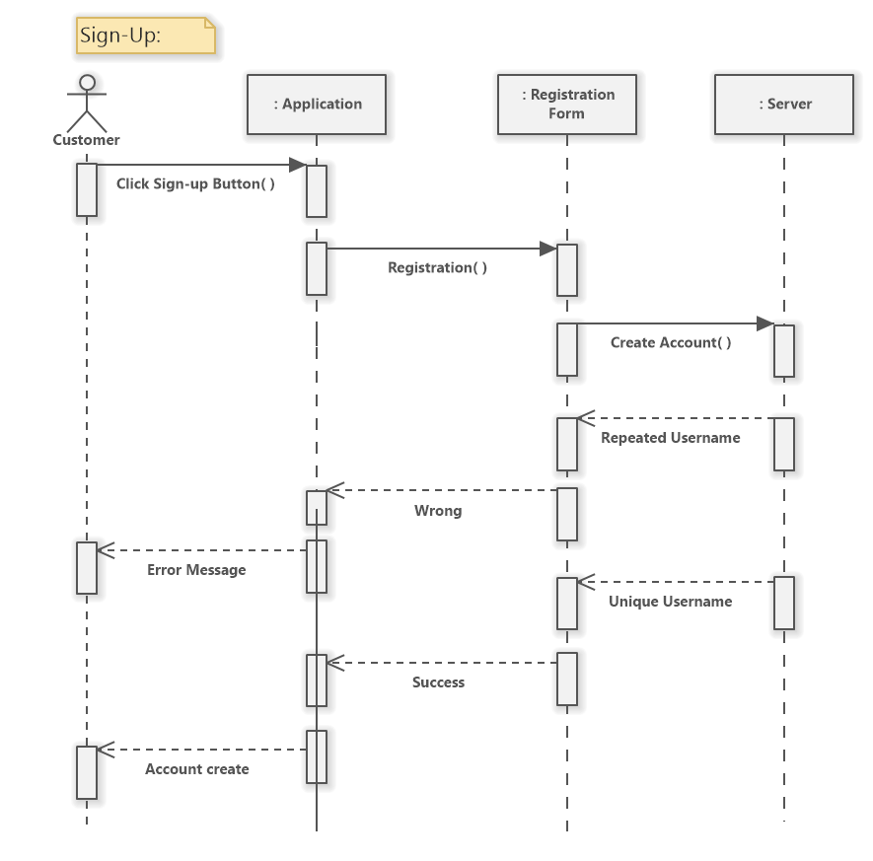A.12

# Class Specification

|  |  |  |
| --- | --- | --- |
| Class: Staff(super class for manger ,employee |  |  |
| Instance variables (Attributes) | Comments |  |
| Staff_ID- - - ->Integer | Unique number of staff |  |
| Staff_pohne - - - ->integer | Staff phone number |  |
| Staff_name - - - ->aString | The name of staff |  |
| Staff_Username - - - ->aString | Unique Password for staff |  |
| Staff_Password - - - ->aString | Password used to login |  |
| Instance variables (Associations) | Comments |  |
| Staff - - - -> Manger  Staff - - - ->employee | * The instance of staff linked via isHeadedBy * The instance of staff linked via ConsistOf |  |
| Instance Methods | Answers |  |
| Login : SUsername, SPassword | Answer the staff |  |
| Logout: | Answer the staff |  |
| Set Staff ID: Staff_ID | Answer the staff |  |
| Get Staff ID: | Answer the staff |  |

|  |  |  |
| --- | --- | --- |
| Class: employee(subclass of staff) |  |  |
| Instance variables (Attributes) | Comments |  |
| Instance variables (Associations) | Comments |  |
| * Employee - - - -> manger * Employee - - - -> staff * Employee - >reservation * Employee - - - -> receipt * Employee - - -> payment | * The instance of Employee linked via WorkFor * The instance of Employee linked via PartsOf * The instance of Employee linked via ChecksOn * The instance of Employee linked via Prints * The instance of Employee linked via ChecksOn |  |
| Instance Methods | Answers |  |
| ConfirmPayment: P_ID, P_Method, R_ID, | Answer the Employee with payment ID, reservation ID and the method cash or visa | a.5 |
| PrintReceipt: Receipt_ID, Payment_ID | Answer the employee with payment id and reservation ID to print receipt | a.11 |
| ConfirmReservation | Answer TRUE if reservation is available |  |

|  |  |  |
| --- | --- | --- |
| Class: Manger(subclass of staff) |  |  |
| Instance variables (Attributes) | Comments |  |
| Instance variables (Associations) | Comments |  |
| * Manger - - - -> Employee * Manger - - - -> staff * Manger - > field * Employee - - - -> Report | * The instance of Employee linked via manges * The instance of Employee linked via PartsOf * The instance of Employee linked via ChecksOn * The instance of Employee linked via CheckOn |  |
| Instance Methods | Answers |  |
| addEmployee: E_ID,E_phone number,E_name,E_username,E_password | Answer the Manger by getting the employee data | a.1 |
| removeEmployee: E_ID,E_phone number,E_name,E_username,E_password | Answer the manger remove employee |  |
| enableField: F_ID, F_name | Answer the manger after checking if field available |  |
| DisableField: F_ID, F_name | Answer the manger in case of something urgent |  |
| GenerateReports: report_ID, Report_type | Answer the manger |  |

|  |  |  |
| --- | --- | --- |
| Class: Report |  |  |
| Instance variables (Attributes) | Comments |  |
| Report_ID- - - ->Integer | Unique number of Report |  |
| Staff_Type - - - ->aString | Type of report |  |
| Instance variables (Associations) | Comments |  |
| Report - - - -> Manger  Report - - - ->Complaint | * The instance of staff linked via WrittenBy * The instance of staff linked via Fullfil |  |
| Instance Methods | Answers and Comments |  |
| ReportSubmit : Boolean | Answer if True ,the manger report has been submitted |  |
| Set Report_ID: R_ID | Answer the manger that is responsible for Complaint |  |
| Get Report_ID: | Answer the manger |  |

|  |  |  |
| --- | --- | --- |
| Class: Complaint |  |  |
| Instance variables (Attributes) | Comments |  |
| Complaint_ID- - - ->Integer | Unique number of staff |  |
| Complaint_Details - - - ->aString | The name of staff |  |
| Instance variables (Associations) | Comments |  |
| * Compliment - - ->Report * Compliment->Customer | * The instance of staff linked via GatheredTo * The instance of staff linked via FullfiledBy |  |
| Instance Methods | Answers and Comments |  |
| CompaintSubmit : Boolean | Answer if True ,the Customer report has been submitted |  |
| Set Complaint_ID: R_ID | Answer the Customer |  |
| Get Complain_ID: | Answer the customer |  |

|  |  |  |
| --- | --- | --- |
| Class: Customer |  |  |
| Instance variables (Attributes) | Comments |  |
| Cus_ID- - - ->Integer | Unique number of Cus |  |
| Cus_pohne - - - ->integer | Cus phone number |  |
| Cus_name - - - ->aString | The name of Cus |  |
| Cus_Username - - - ->aString | Unique Password for Cus |  |
| Cus_Password - - - ->aString | Password used to login |  |
| Instance variables (Associations) | Comments |  |
| * Customer -> Complaint * Customer ->Reservation * Customer - - ->Payment | * The instance of Customer linked via Submit * The instance of Customer linked via make * The instance of Customer linked via make |  |
| Instance Methods | Answers |  |
| CusLogin : CUsername, CPassword | Answer the Customer | a.6 |
| CusLogout: | Answer the Customer |  |
| Make Reservation: Name, phone number, datetime, field, addAddon | Answer the Customer | a.9 |
| Cancel Reservation: datetime, field | Answer the Employee to cancel reservation | a.4 |
| Modify Reservation: datetime, field | Answer the Employee to Change reservation time or field | a.10 |
| Make complaint: complaint details | Answer the Customer to complaint to be submitted to manger | a.7 |
| Browse available Fields: field_ID | Answer the customer to employee | a.3 |
| Make payment: payment_method, Reservation res | Answer the customer to employee | a.8 |
| Get Customer_ID: cus_ID | Answer the Customer |  |
| Set Customer_ID: | Answer the Customer |  |

|  |  |  |  |
| --- | --- | --- | --- |
| Class: Reservation |  |  | |
| Instance variables (Attributes) | Comments |  | |
| Reservation_ID- - - ->Integer | Unique number of Reservation |  | |
| Reference_Code - - - ->aString | Reference Code |  | |
| Total_price- - - ->Integer | The amount per hour for each field |  | |
| Reservation_DateTime ->aString | Amount of time |  | |
| Reservation_status - - ->bool | If reservation is available |  | |
| Addon_ID: Integer | Unique number for addon |  | |
| Instance variables (Associations) | Comments |  | |
| * Reservation-> Customer * Reservation ->Employee * Reservation- ->Payment * Reservation - - ->field | * The instance of Reservation linked via fullfill * The instance of Reservation linked via confirmedBy * The instance of Reservation linked via include * The instance of Reservation linked via checksOn | |  |
| Instance Methods | Answers |  | |
| Set Reservation_ID : | Answer the employee |  | |
| Get Reservation_ID: | Answer the Employee |  | |
| Set Addon_ID: addon_ID | Answer the Emploee |  | |
| Get Addon_ID: | Answer the Employee |  | |
| checkifAddonAvailable: | Answer the Employee |  | |

Table of Contents

Table of Participants 1

Architecture Design 2

Initial Class 3

Use Case Diagram 4

Class Diagram 5

Sequence Diagram 6

Class Specification 16